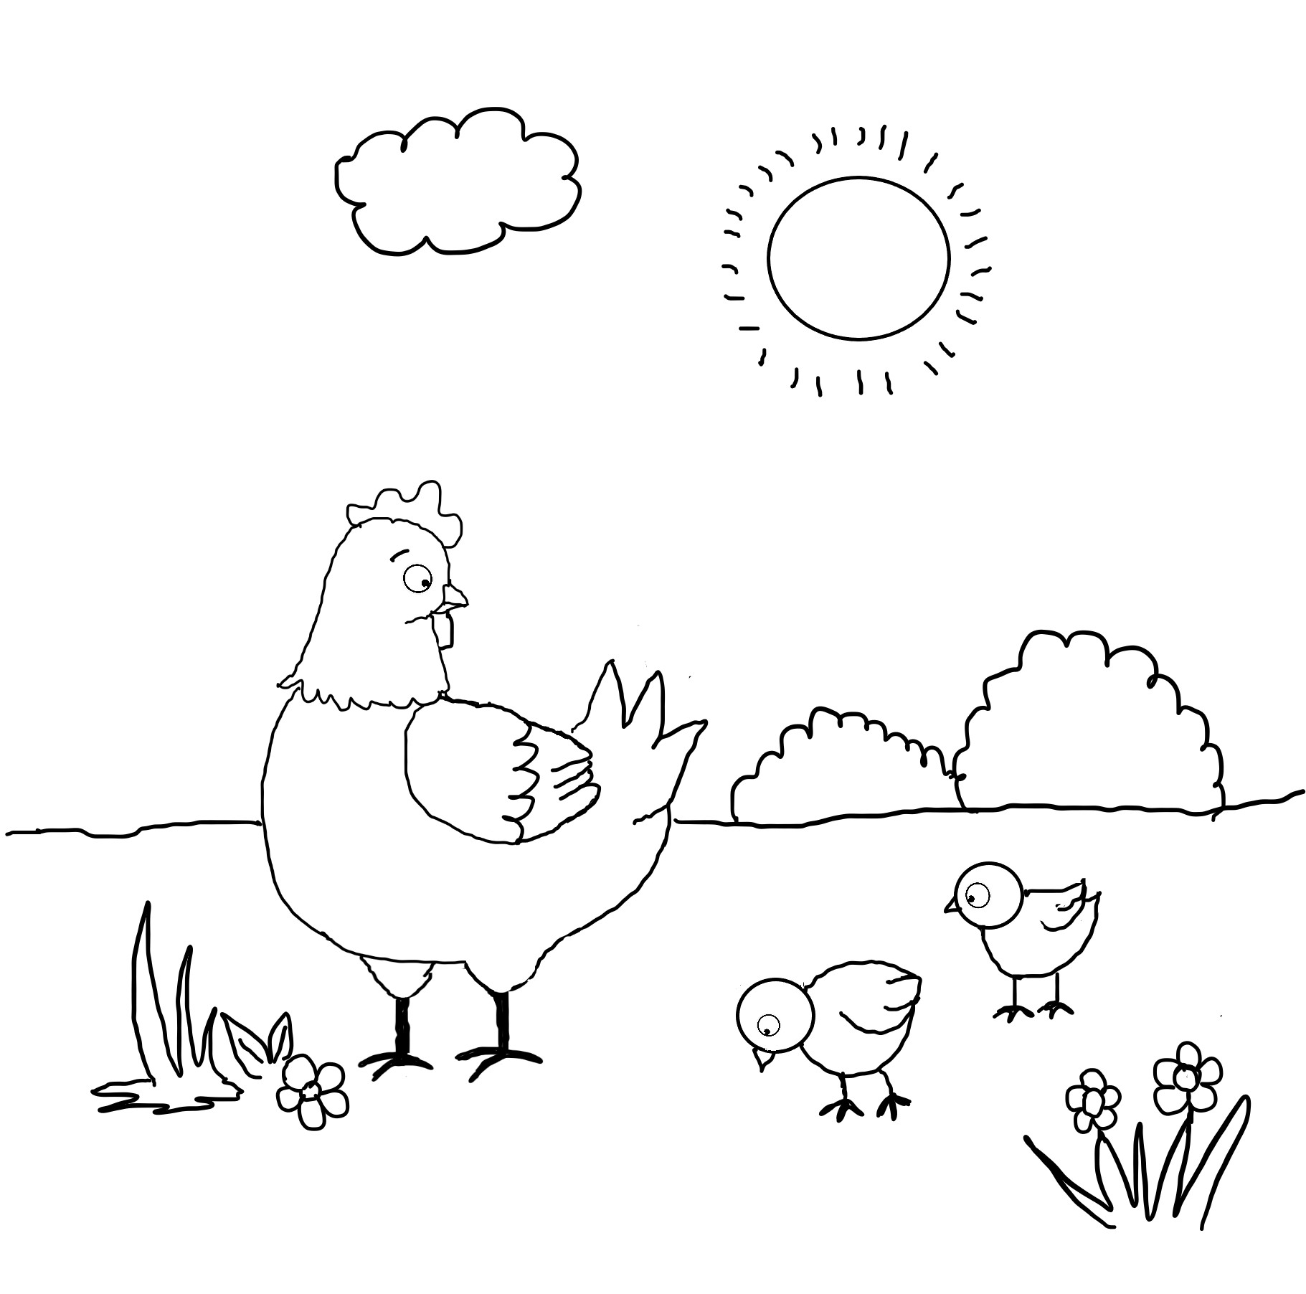

Let’s have fun coloring the mother hen and her two chicks.

Name:

Mother Hen and Chicks

Story: The Adventure of Mother Hen and Her Ten Eggs