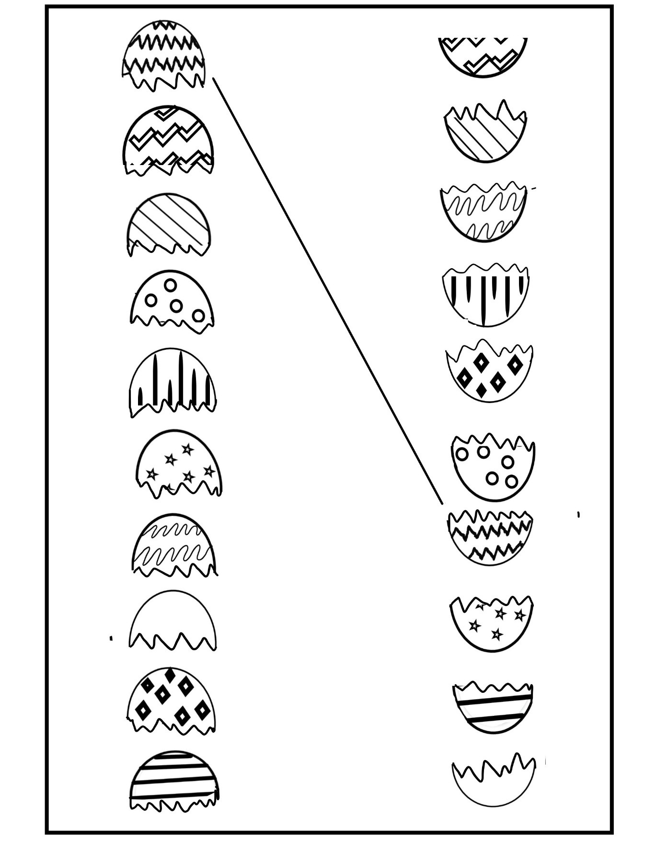

Egg-stra Fun

Story: The Adventure of Mother Hen and Her Ten Eggs

Name: