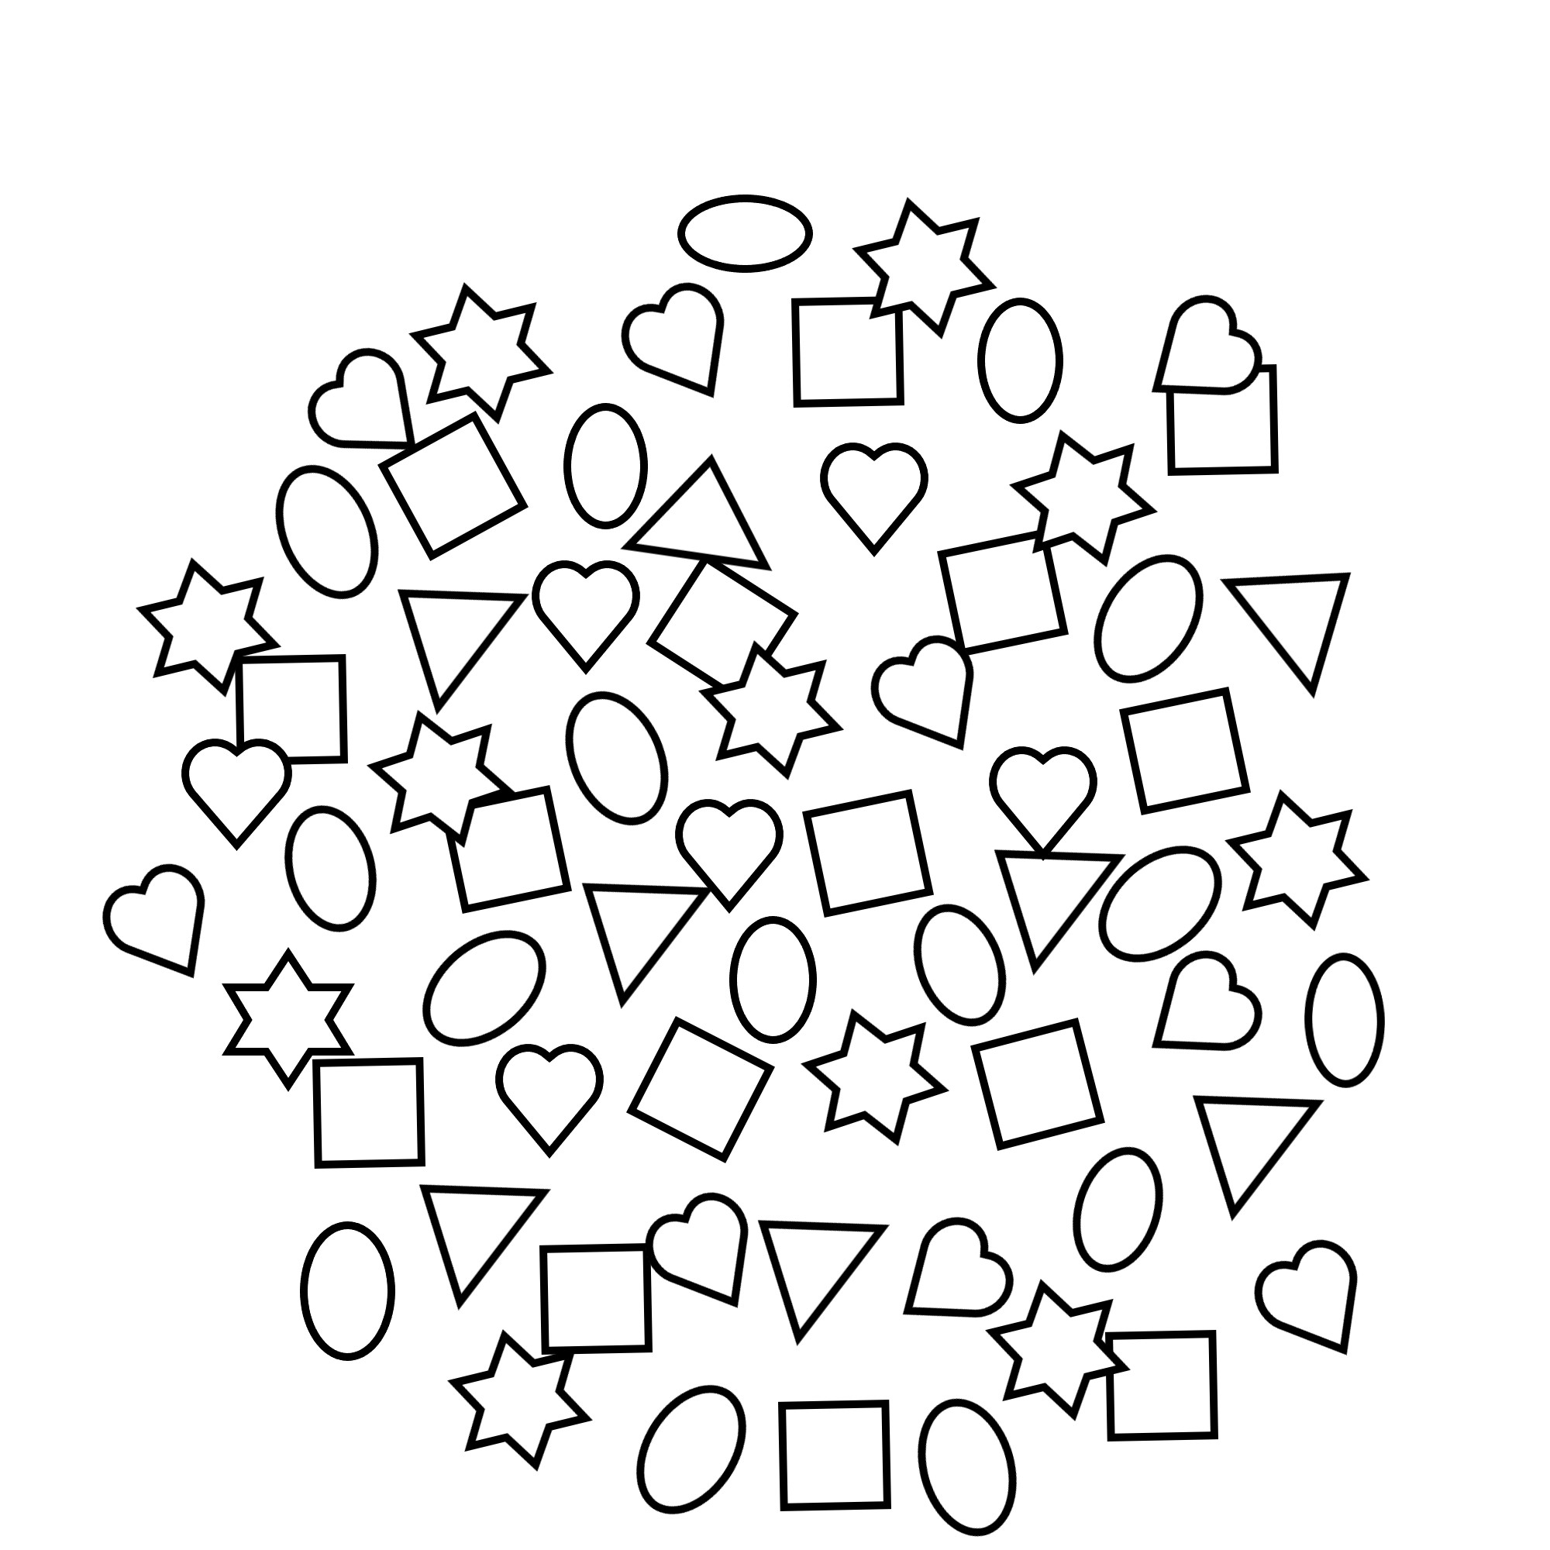

No. of eggs

No. of hearts

No. of stars

No. of squares

Count the Eggs

Story: The Adventure of Mother Hen and Her Ten Eggs

Count and colour the eggs.

Name: