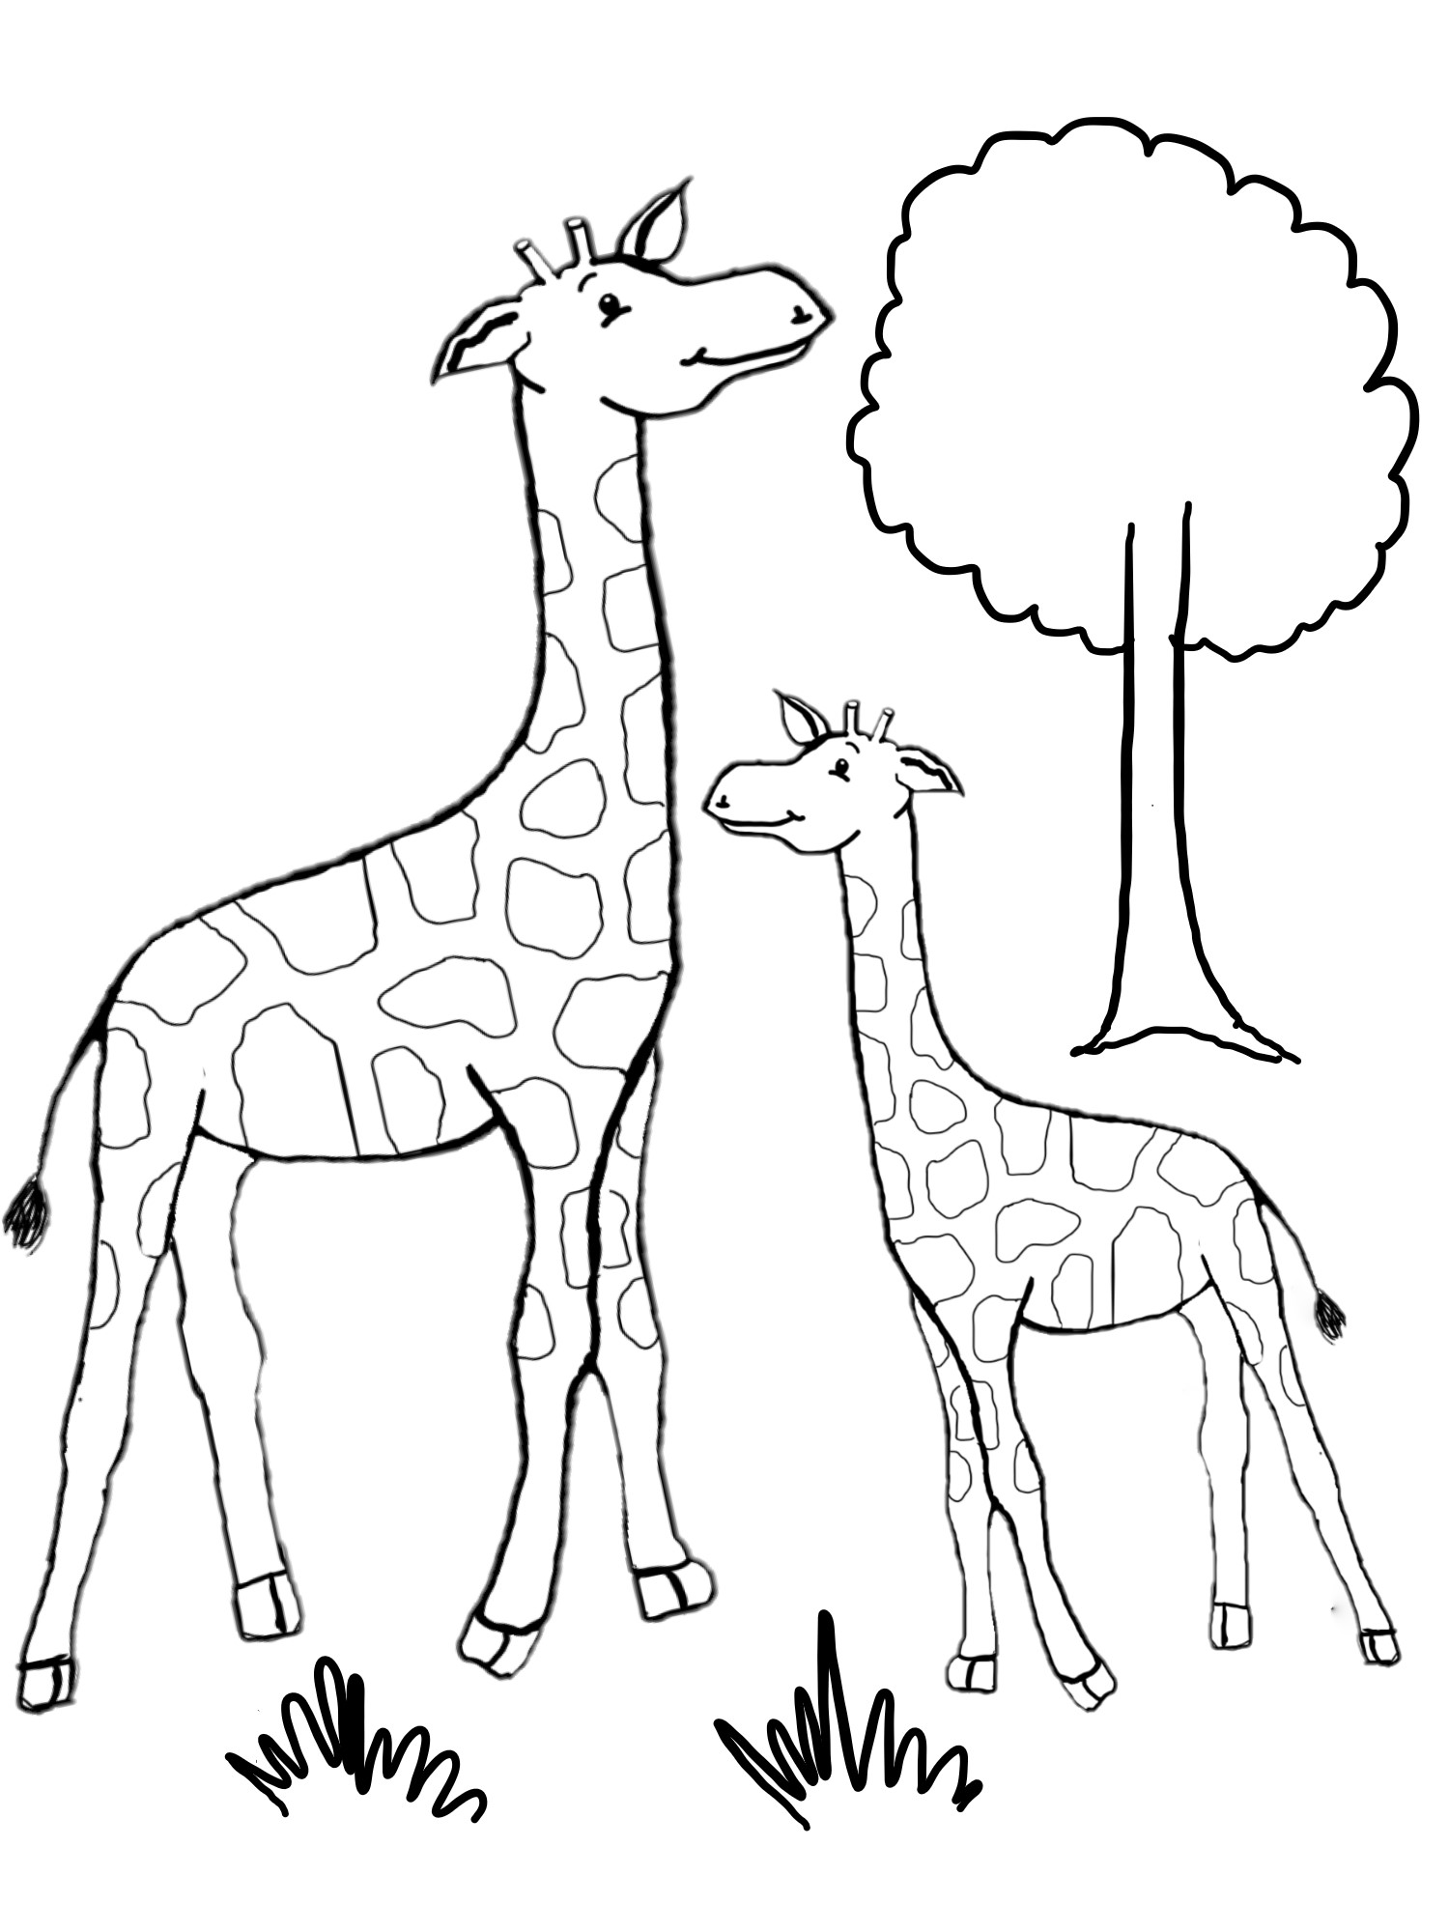

Name:

Fingerprint Giraffes

Mr. Hedgehog and his Missing Spectacles