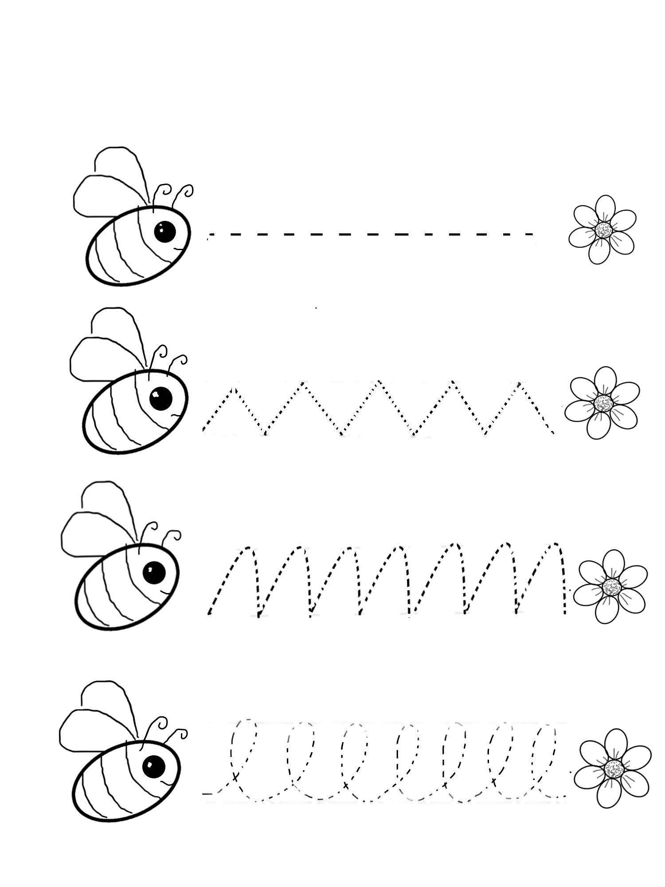

Name:

Trace the lines and colour the picture

Trace the Lines

Story: Bia the Bee Learns to Dance