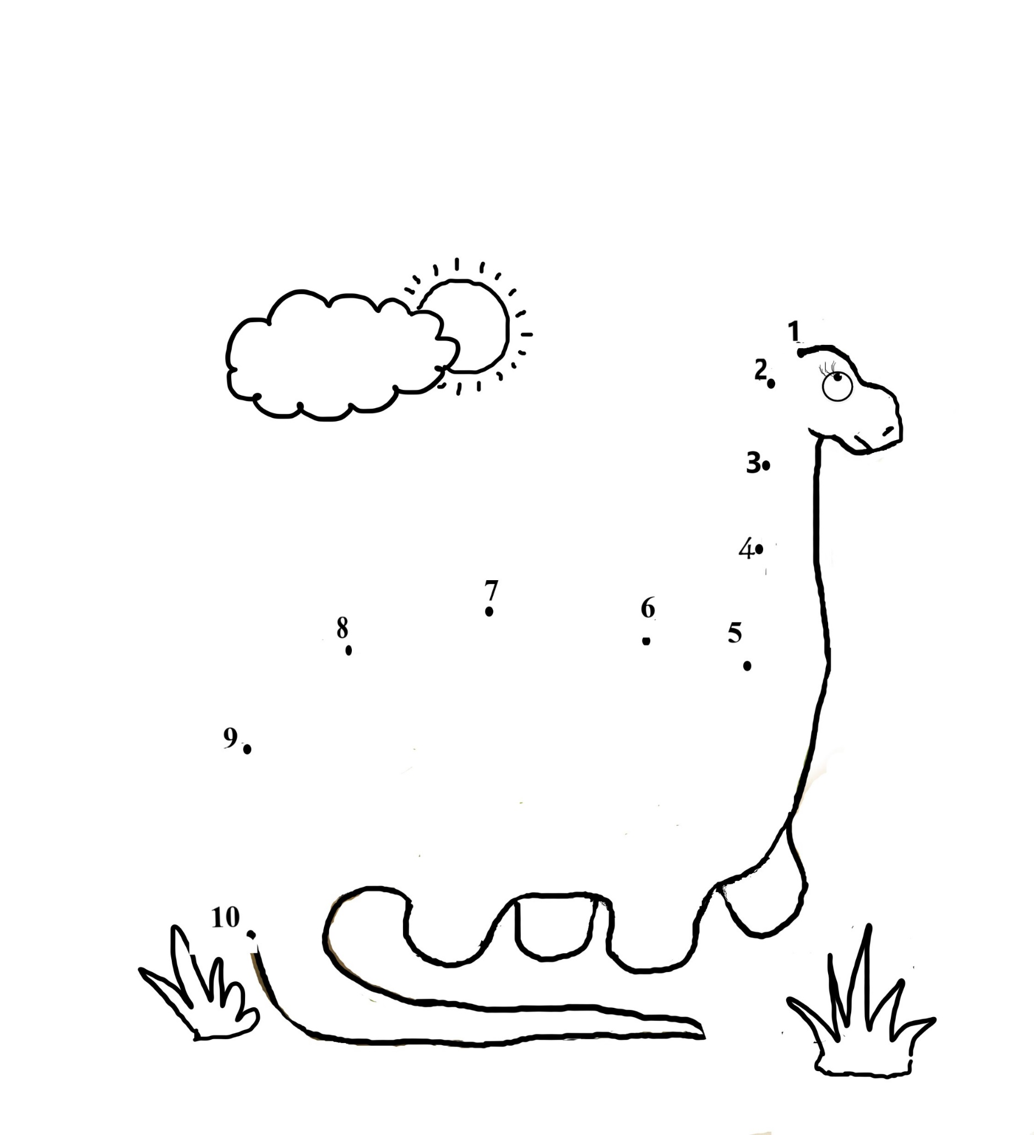i

Name:

Connect numbers from 1-10 and colour!

Story: The Higgledy-Piggledy Spiders

Dinosaur Dot to Dot