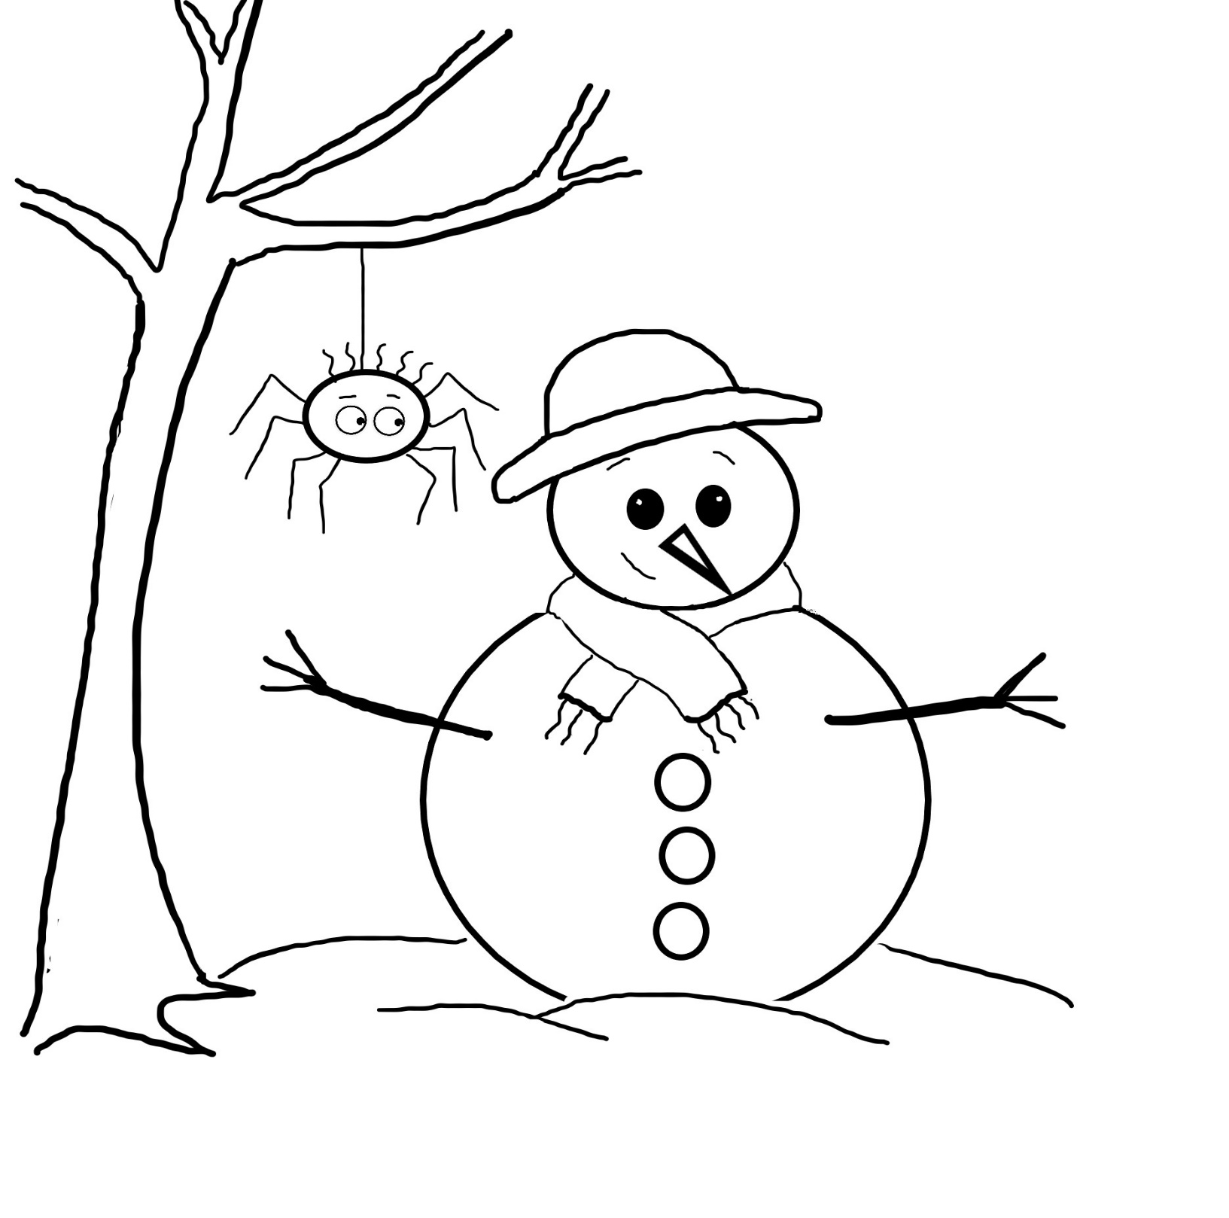

Name:

Colour the Picture

Story: The Higgledy-Piggledy Spiders