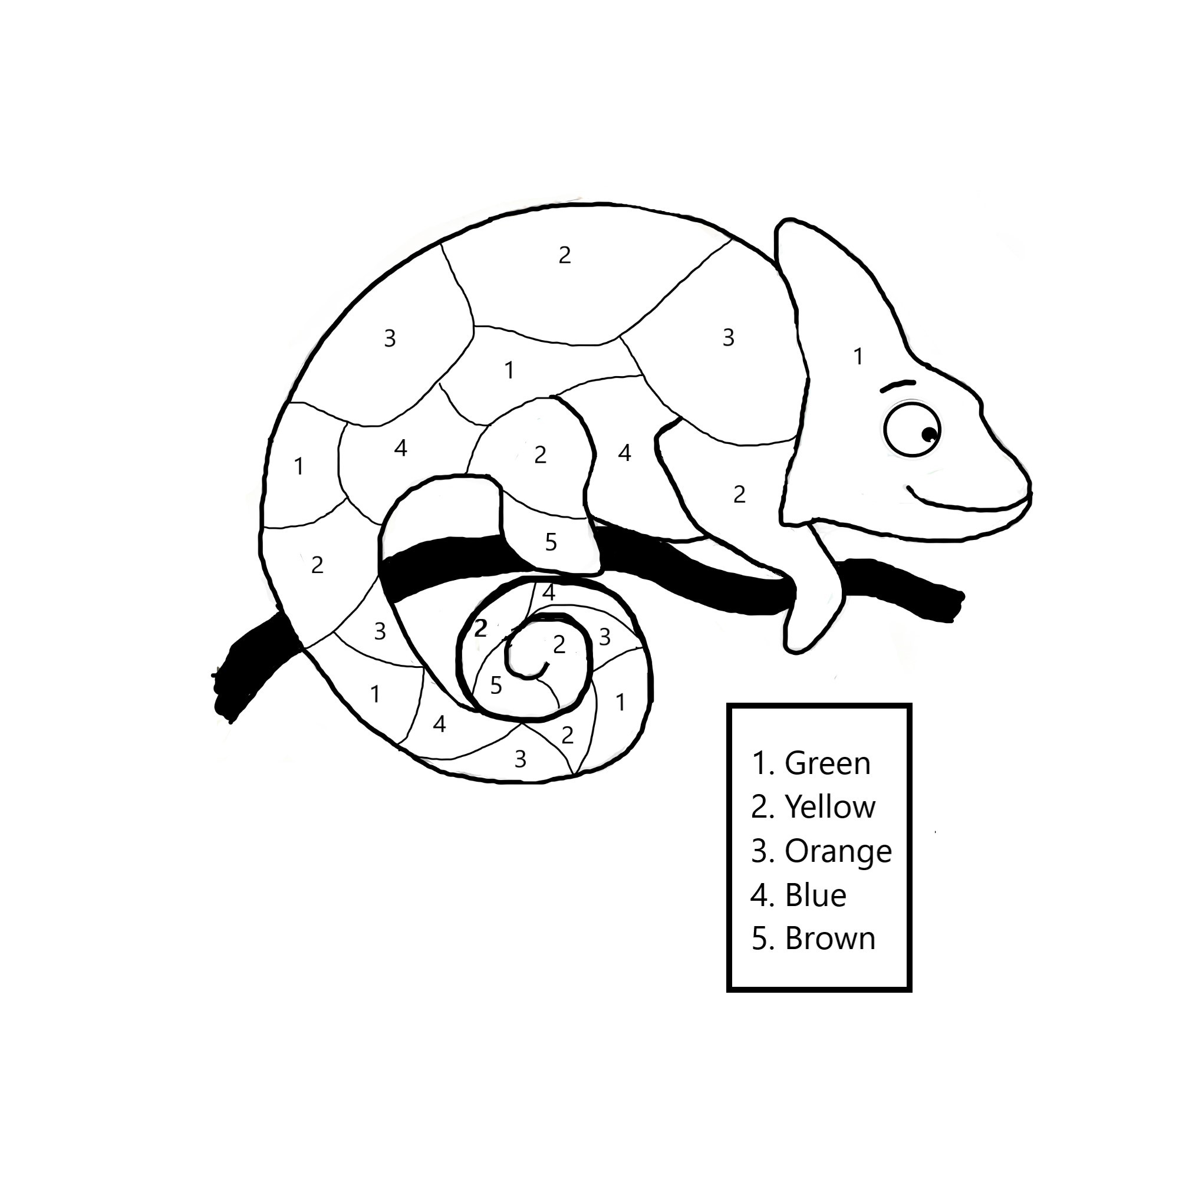

Name:

Story: Bia the Bee Learns to Dance

Colour the Chameleon