Bee Puzzle

Story: Bia the Bee Learns to Dance

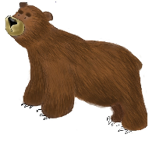

1. BEAR

2. TALL

3. FLOWERS

4. BEE

5. QUEEN

6. LIKE

7. DANCE

8. OAK

9. ROYAL JELLY

10. ONE

11.HAPPY

12. SAD

13. BIG

14. HONEY

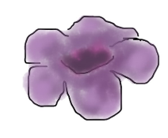

Name:

**1**