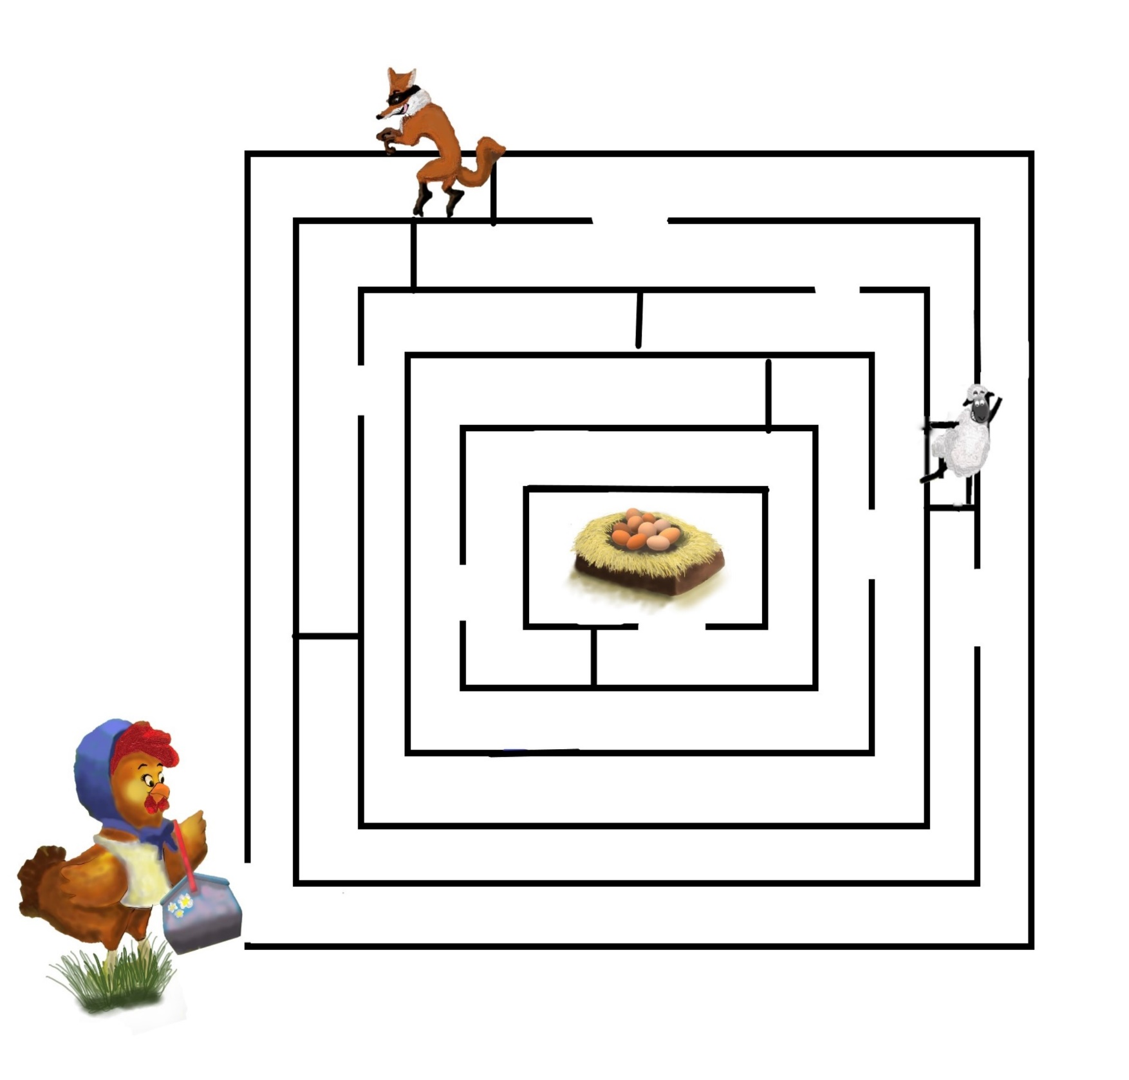

Mother Hen Maze

Story: The Adventures of Mother Hen and Her Ten Eggs

Name:

Help Mother Hen get through the maze to reach her nest. Watch out for the sly fox and silly sheep!