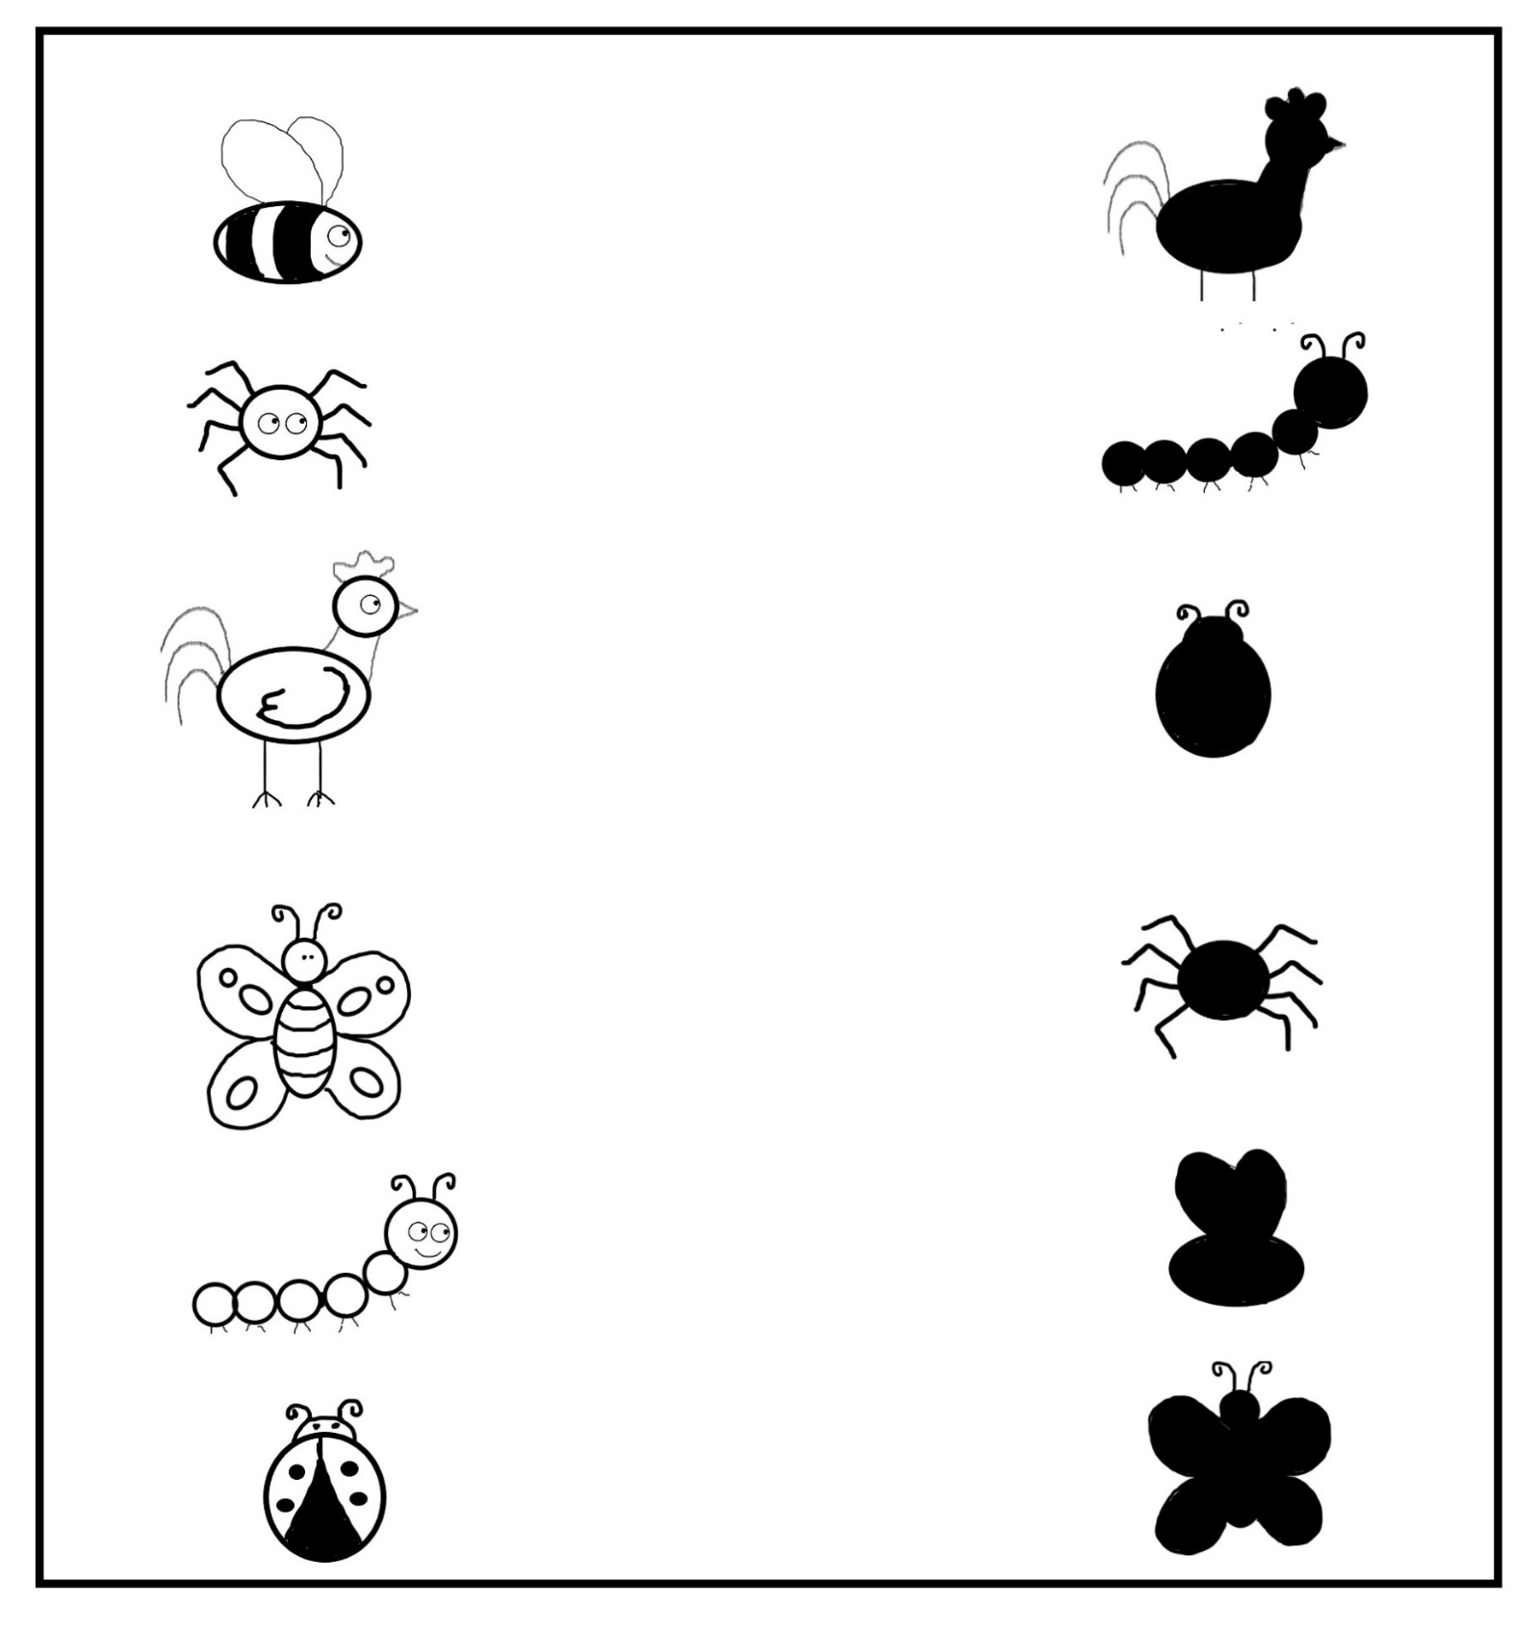

Shadow Matching Game

Draw a line matching each picture to its shadow

Name: