\

Count and Match

Story: The Higgledy- Piggledy Spiders

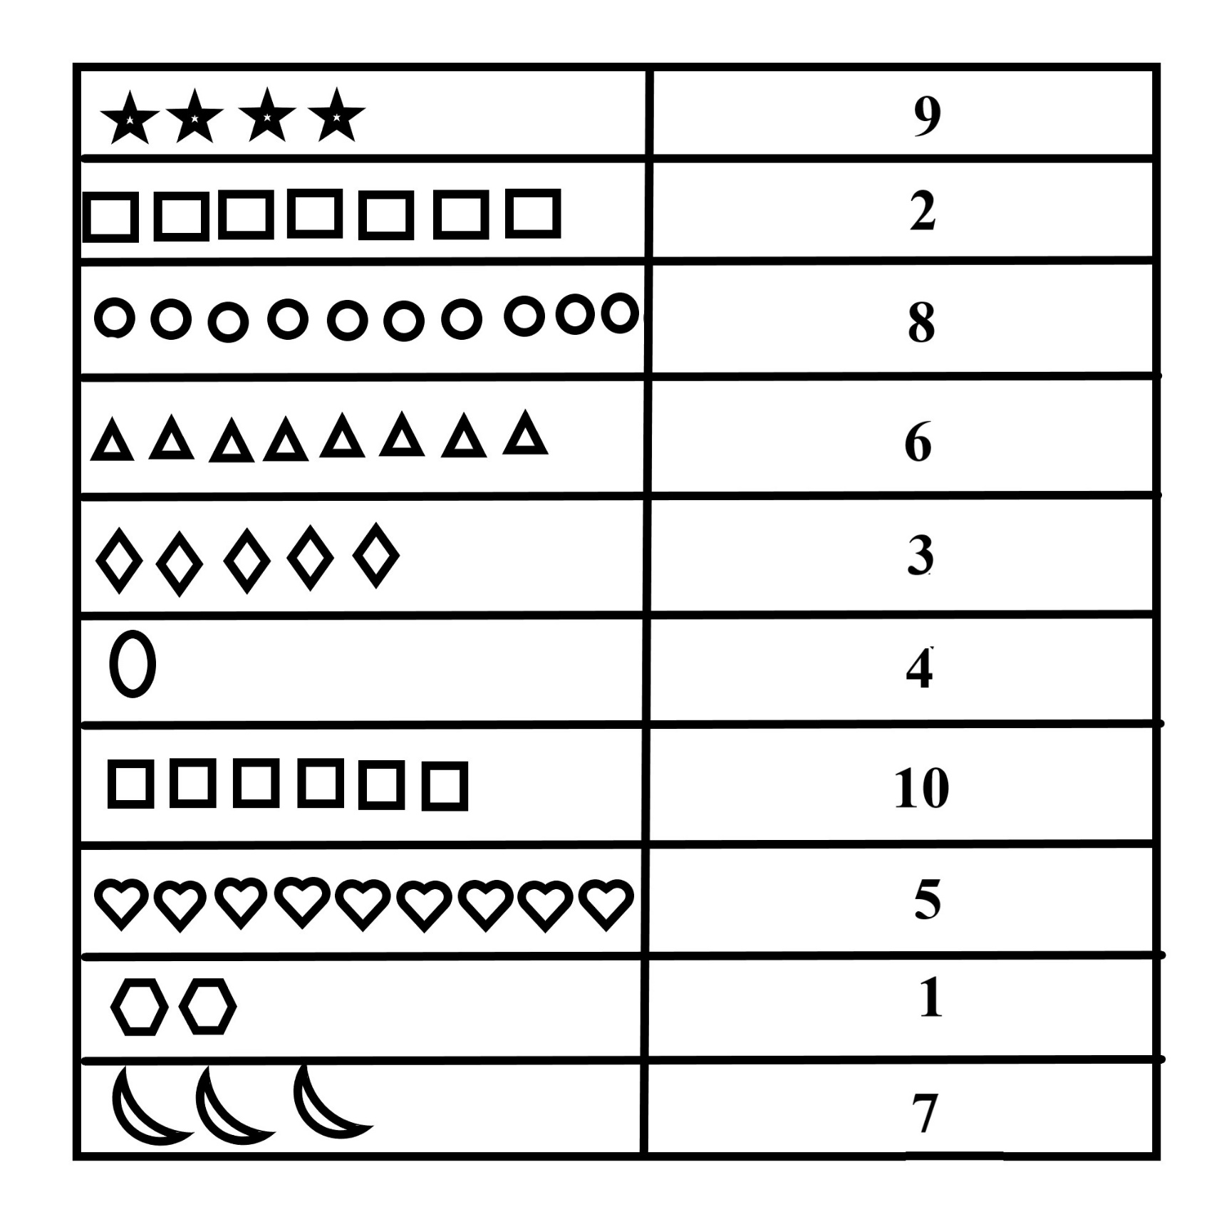

Name: