Count the Chicks
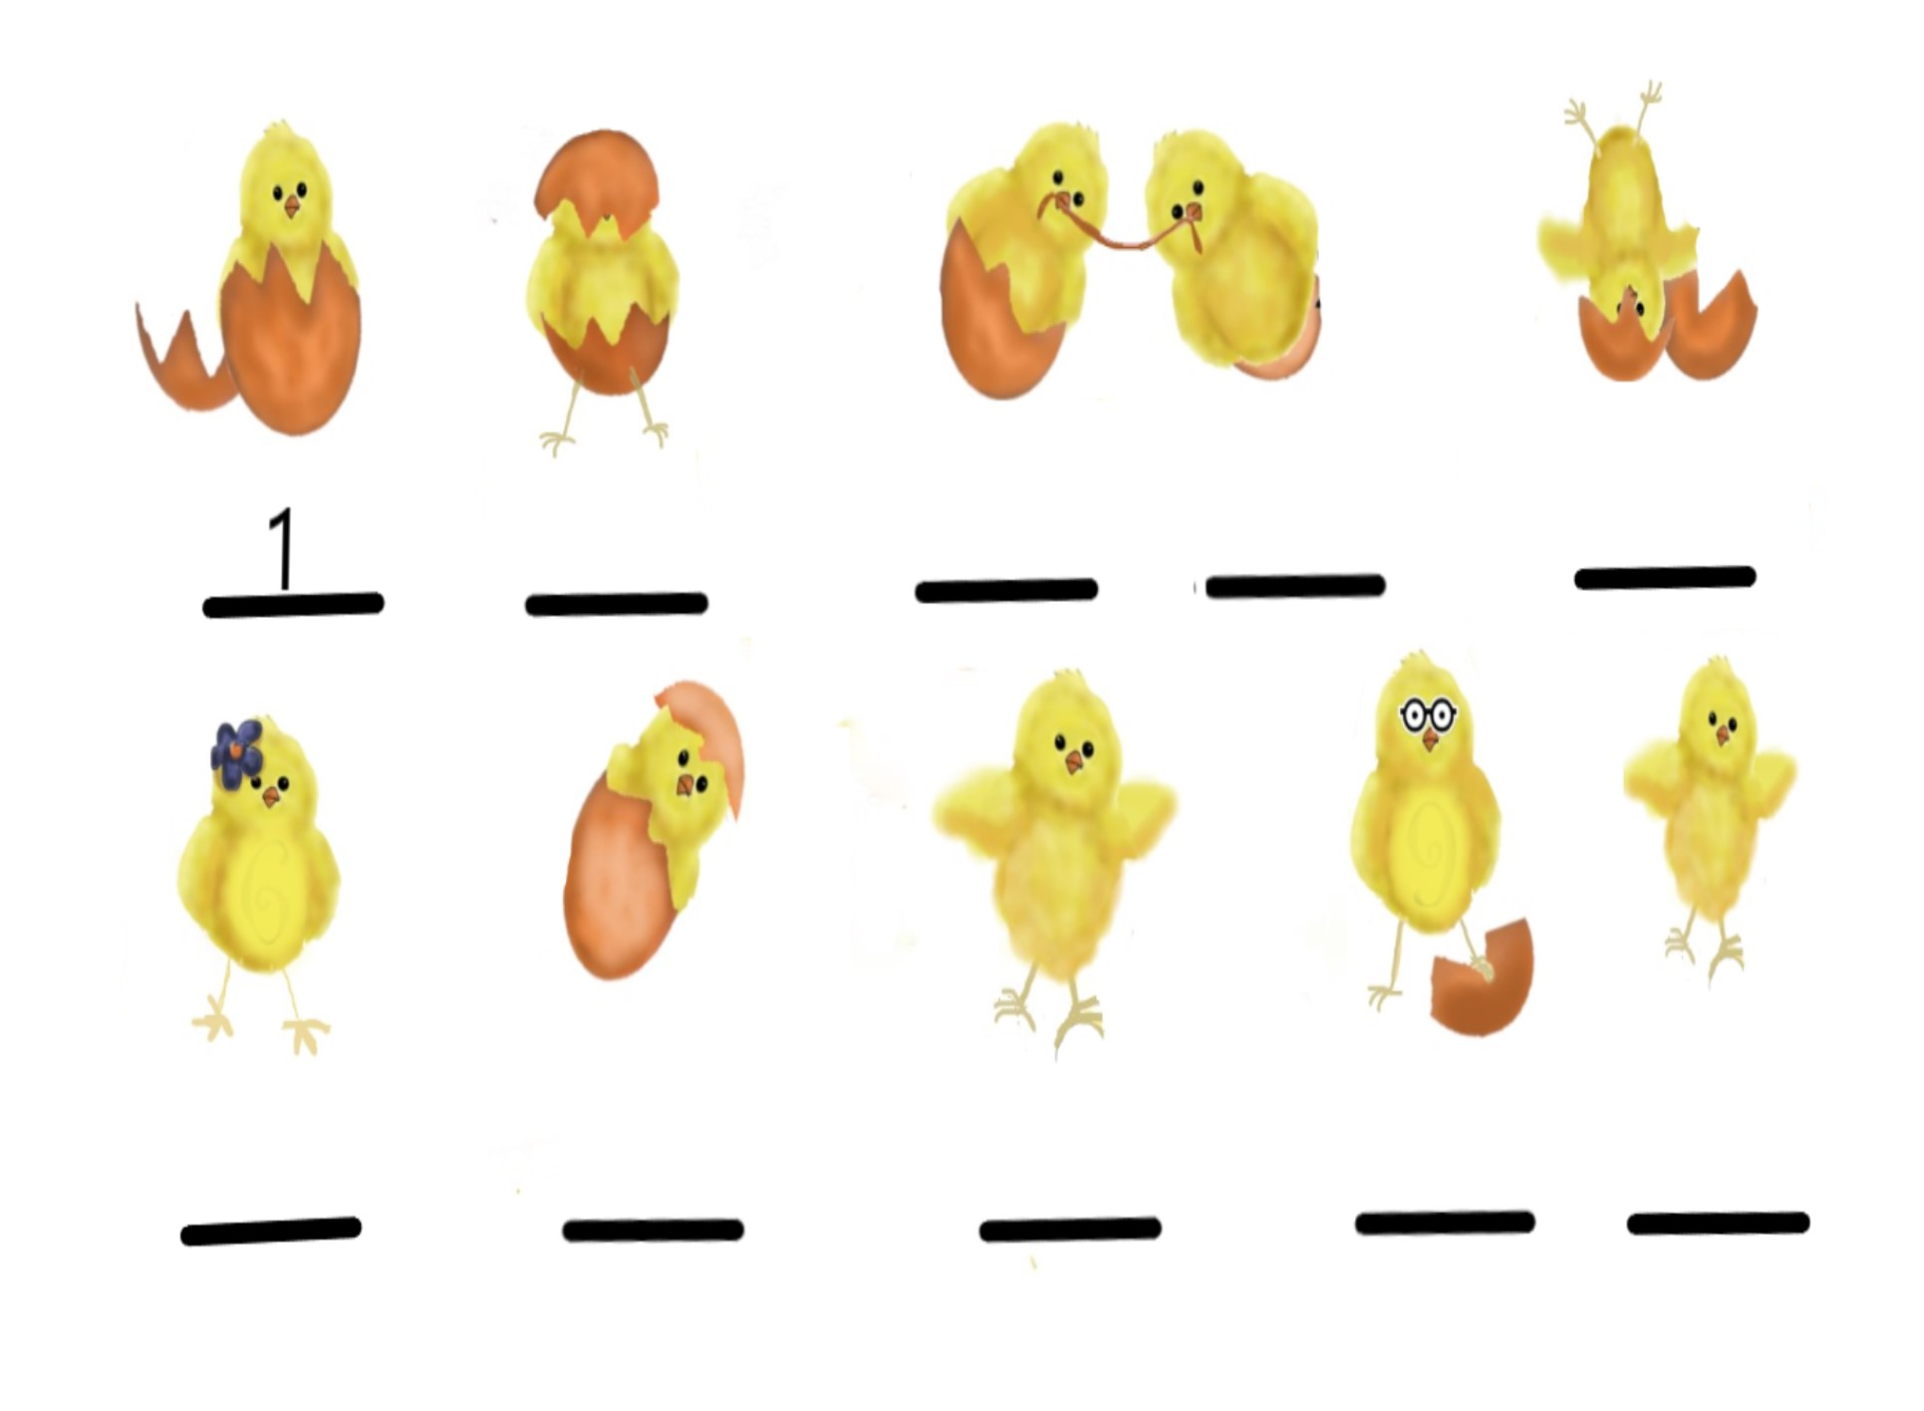
Story: The Adventure of Mother Hen and Her Ten Eggs
Name:

