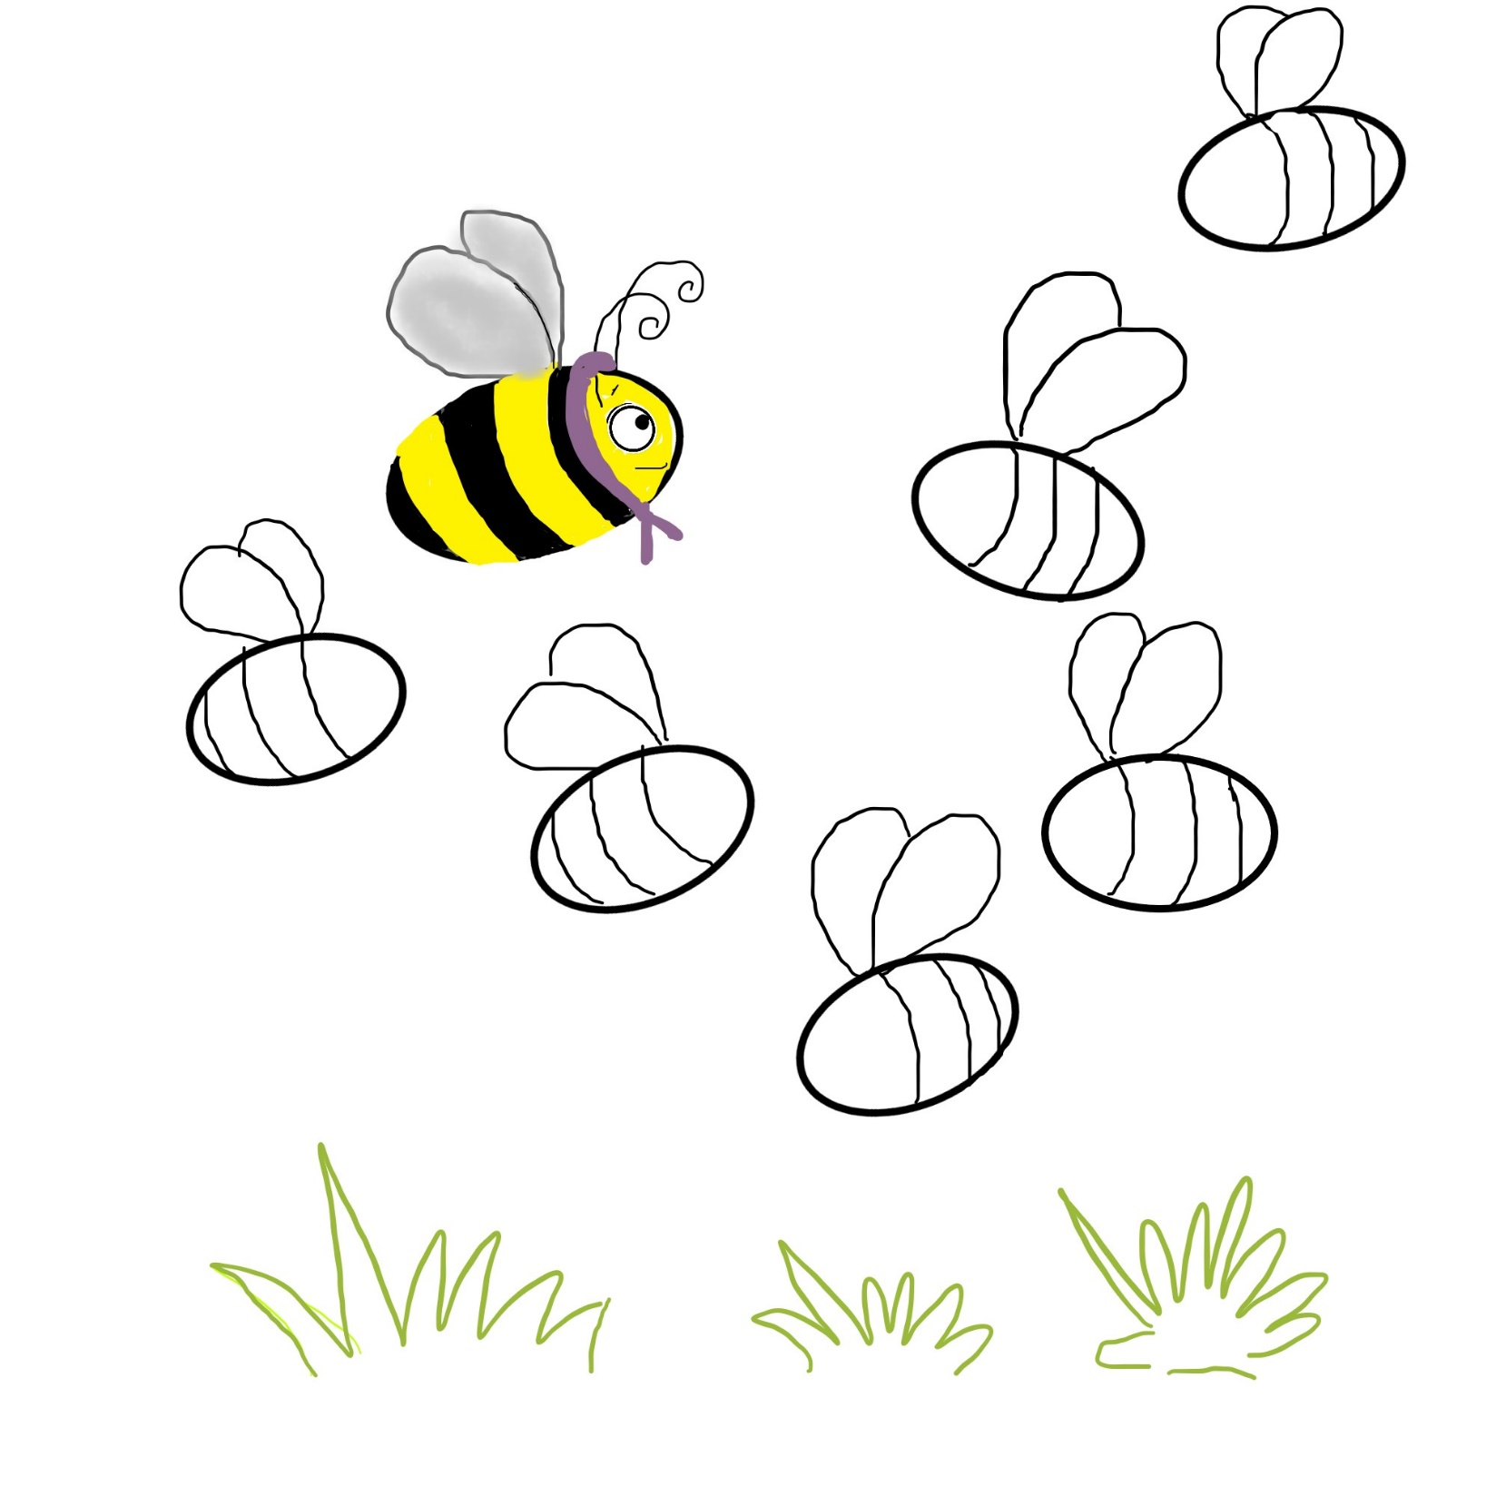

Name:

Complete the picture and have fun making thumb- print bees.

Thumb-Print Bees

Story: Bia the Bee Learns to Dance