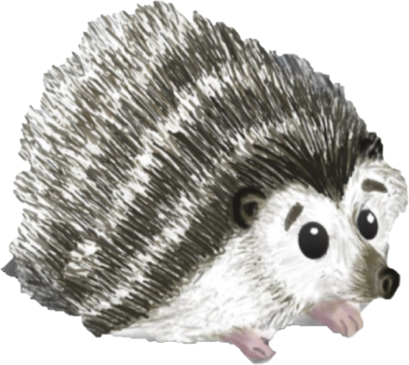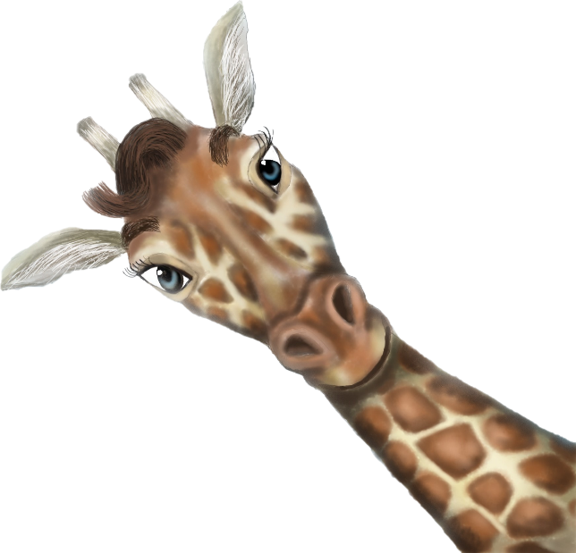

Name:

Age:

Favourite Food:

Favourite Animal:

I love to

Me

My Friends

When I grow up, I want to be

All About Me