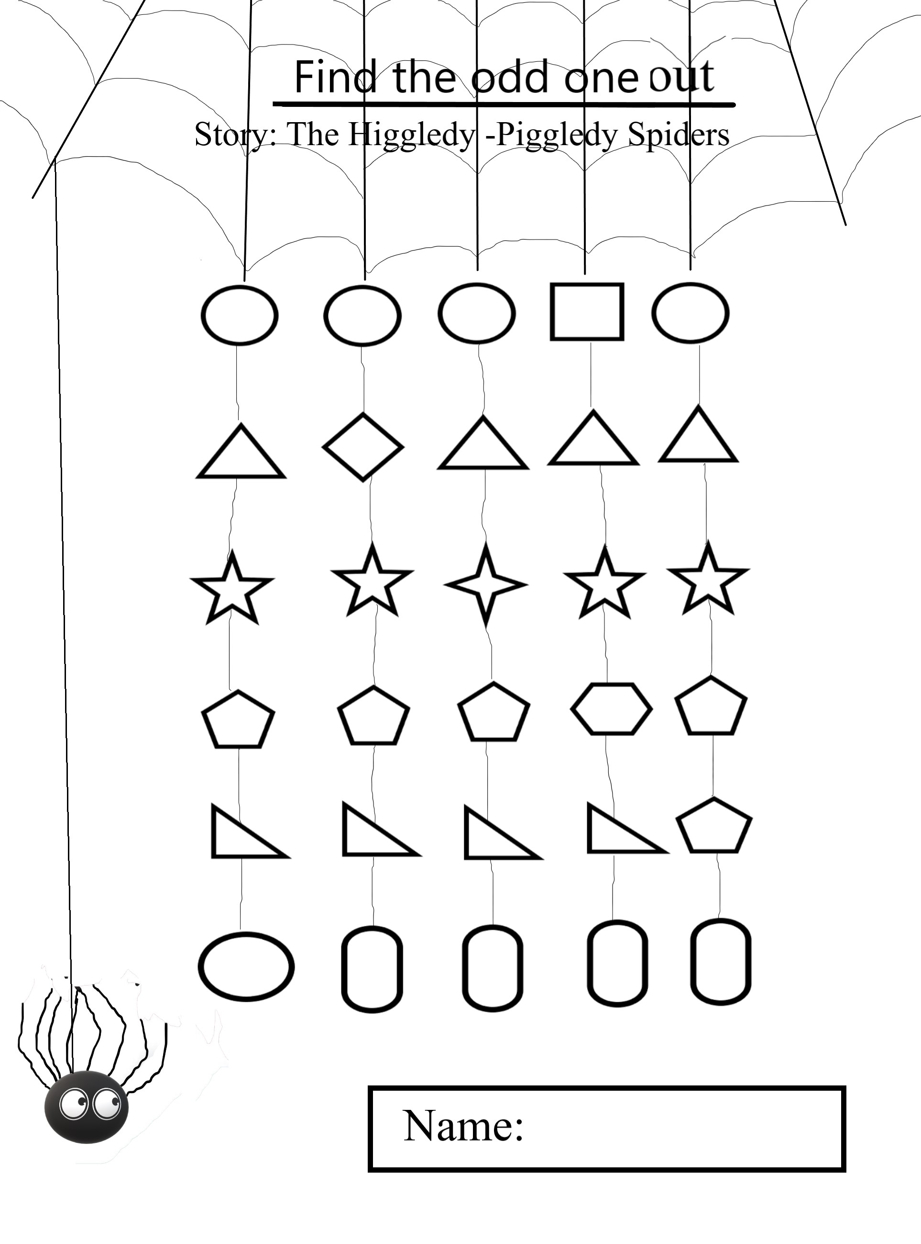

Find the odd one out in each row and colour it